DBMS – SUPPLIER AND INVENTORY MANAGEMENT
Project Title: Vilvah – Natural Skincare and Personal Care Database Management System

Introduction
The Vilvah Supplier and Inventory Management System is designed to manage supplier information and product inventory for the Vilvah natural skincare and personal care database.
The system maintains important supplier details such as Supplier ID, Supplier Name, Contact Person, Phone, Email, City and GST Number. It also manages inventory information including Inventory ID, Product ID, Quantity, Minimum Stock, Warehouse and Last Updated.
The system establishes relationships between Suppliers, Products and Inventory to maintain accurate product and stock information. It also helps track available and unavailable products, update inventory quantities and generate inventory status reports.
This module improves inventory management by providing clear information about product availability, stock levels, suppliers and warehouse details.

1. Database Design

1.1 Supplier Table
Attribute | Data Type | Key | Description
Supplier_ID | INT | PK | Unique supplier ID
Supplier_Name | VARCHAR(100) | - | Supplier name
Contact_Person | VARCHAR(100) | - | Contact person
Phone | VARCHAR(15) | - | Supplier phone number
Email | VARCHAR(100) | - | Supplier email
City | VARCHAR(50) | - | Supplier city
GST_Number | VARCHAR(20) | - | GST number

1.2 Inventory Table

Attribute | Data Type | Key | Description
Inventory_ID | INT | PK | Unique inventory ID
Product_ID | INT | FK | References Product
Quantity | INT | - | Available quantity
Minimum_Stock | INT | - | Minimum required stock
Warehouse | VARCHAR(100) | - | Warehouse location
Last_Updated | DATE | - | Last updated date
2 . Table Creation

2.1 Create Supplier Table

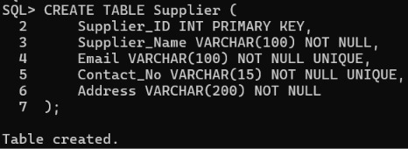

2.2 Create Inventory Table

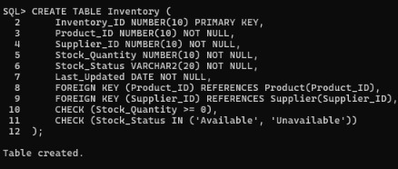

2.3 Supplier Data Insertion

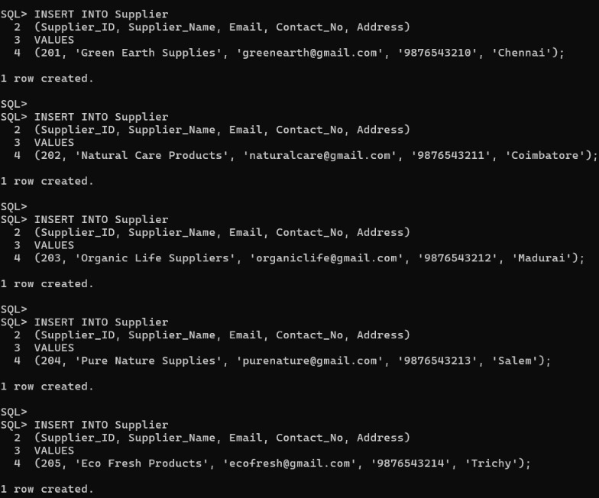

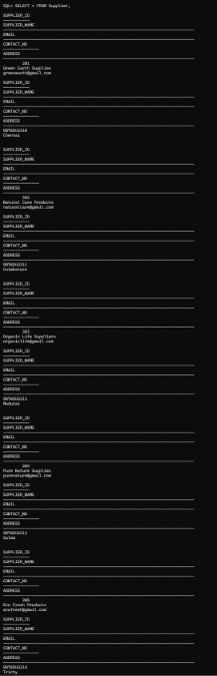

2.4 Inventory Data Insertion

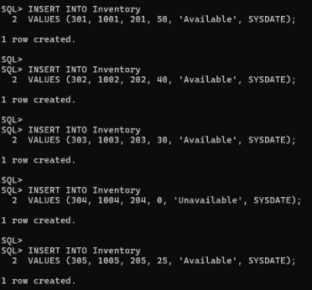
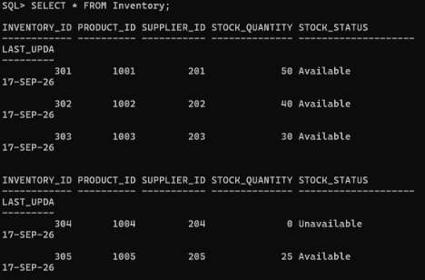

2.5 Supplier Product Information

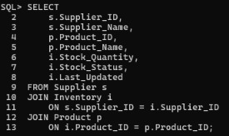

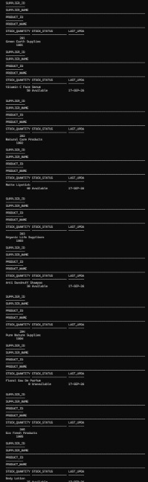

Inventory Status

3.1 Display Available Products
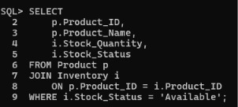

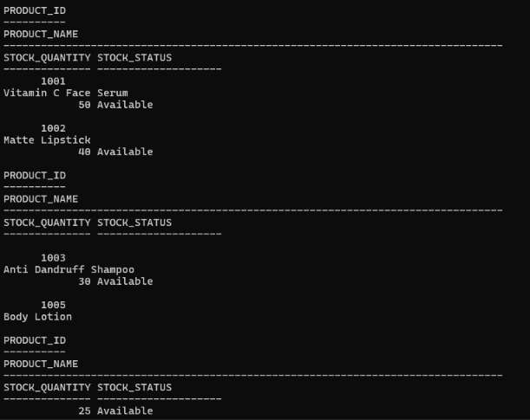

4.Display Unavailable Products

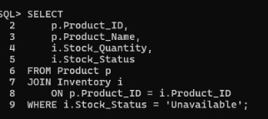
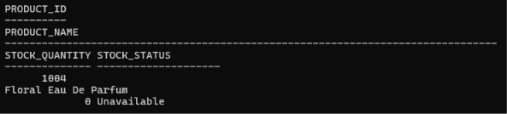

5. Inventory Update

5.1 Update Inventory Quantity
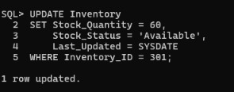

- Inventory Status Reports

6.1 Complete Inventory Report
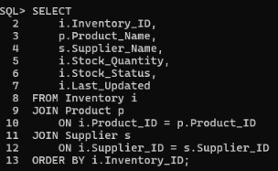

6.2 Available and Unavailable Product Count
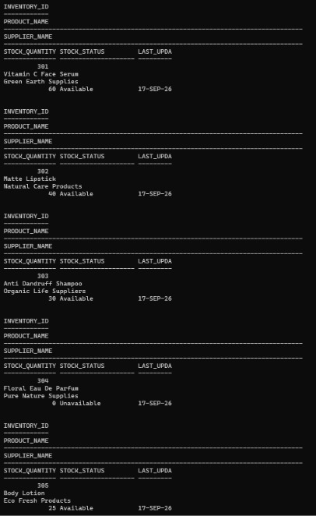

6.3 Total Stock by Supplier

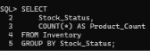

6.4 Products with Zero Stock

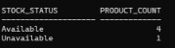

- Total Stock by Supplier

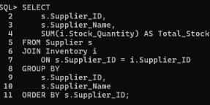
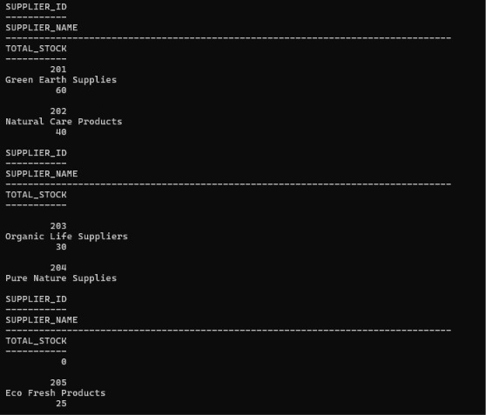

- Products with Zero Stock

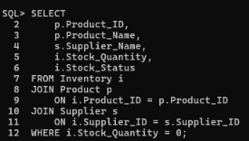
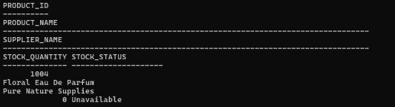

10.Conclusion
The Vilvah Supplier and Inventory Management System successfully manages supplier and inventory information and establishes relationships between suppliers, products and stock.
Primary key and foreign key constraints help maintain data integrity and connect the Supplier, Product and Inventory tables. The system supports supplier data insertion, inventory management, stock updates and identification of available and unavailable products.
The inventory status reports provide useful information about product quantities, stock levels, warehouses and suppliers. Overall, this module provides a structured approach to managing supplier and inventory information in the Vilvah DBMS project.

